**I. Hardware**

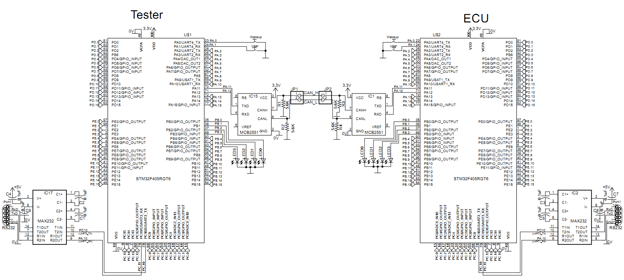

**II. Software**

**A. GPIO_ Configuration for Led (LED1->LED4)**

void GPIO_Configuration(void)

{

GPIO_InitTypeDef GPIO_InitStructure;

RCC_AHB1PeriphClockCmd(RCC_AHB1Periph_GPIOB, ENABLE);

//LED1 (PC9) LED2 (PC10) LED3 (PC11) LED4 (PC12)

GPIO_InitStructure.GPIO_Pin = GPIO_Pin_0 | GPIO_Pin_1| GPIO_Pin_2| GPIO_Pin_3;

GPIO_InitStructure.GPIO_Mode = GPIO_Mode_OUT;

GPIO_InitStructure.GPIO_OType = GPIO_OType_PP;

GPIO_InitStructure.GPIO_Speed = GPIO_Speed_100MHz;

GPIO_InitStructure.GPIO_PuPd = GPIO_PuPd_NOPULL;

GPIO_Init(GPIOB, &GPIO_InitStructure);

}

**B. UART3_ Configuration for monitoring**

void USART_Configuration(void)

{

GPIO_InitTypeDef GPIO_InitStructure;

USART_InitTypeDef USART_InitStructure;

RCC_AHB1PeriphClockCmd(Open_USARTx_TX_GPIO_CLK,ENABLE);

RCC_AHB1PeriphClockCmd(Open_USARTx_RX_GPIO_CLK,ENABLE);

#if defined OpenUSART1 || defined OpenUSART6

RCC_APB2PeriphClockCmd(Open_USARTx_CLK,ENABLE);

#else

RCC_APB1PeriphClockCmd(Open_USARTx_CLK,ENABLE);

#endif

GPIO_PinAFConfig(Open_USARTx_TX_GPIO_PORT, Open_USARTx_TX_SOURCE, Open_USARTx_TX_AF);

GPIO_PinAFConfig(Open_USARTx_RX_GPIO_PORT, Open_USARTx_RX_SOURCE, Open_USARTx_RX_AF);

/*

* Open_USARTx_TX -> PA9 , Open_USARTx_RX -PA10

*/

GPIO_InitStructure.GPIO_Pin = Open_USARTx_TX_PIN;

GPIO_InitStructure.GPIO_Mode = GPIO_Mode_AF;

GPIO_InitStructure.GPIO_OType = GPIO_OType_PP;

GPIO_InitStructure.GPIO_Speed = GPIO_Speed_50MHz;

GPIO_InitStructure.GPIO_PuPd = GPIO_PuPd_UP;

GPIO_Init(Open_USARTx_TX_GPIO_PORT, &GPIO_InitStructure);

GPIO_InitStructure.GPIO_Pin = Open_USARTx_RX_PIN;

GPIO_InitStructure.GPIO_OType = GPIO_OType_OD;

GPIO_InitStructure.GPIO_PuPd = GPIO_PuPd_NOPULL;

GPIO_Init(Open_USARTx_RX_GPIO_PORT, &GPIO_InitStructure);

#if defined HwFlowControl && !defined OpenUART4 && !defined OpenUART5

RCC_AHB1PeriphClockCmd(Open_USARTx_RTS_GPIO_CLK,ENABLE);

RCC_AHB1PeriphClockCmd(Open_USARTx_CTS_GPIO_CLK,ENABLE);

GPIO_PinAFConfig(Open_USARTx_RTS_GPIO_PORT, Open_USARTx_RTS_SOURCE, Open_USARTx_RTS_AF);

GPIO_PinAFConfig(Open_USARTx_CTS_GPIO_PORT, Open_USARTx_CTS_SOURCE, Open_USARTx_CTS_AF);

GPIO_InitStructure.GPIO_Pin = Open_USARTx_RTS_PIN;

GPIO_InitStructure.GPIO_Mode = GPIO_Mode_AF;

GPIO_InitStructure.GPIO_OType = GPIO_OType_PP;

GPIO_InitStructure.GPIO_Speed = GPIO_Speed_50MHz;

GPIO_InitStructure.GPIO_PuPd = GPIO_PuPd_UP;

GPIO_Init(Open_USARTx_RTS_GPIO_PORT, &GPIO_InitStructure);

GPIO_InitStructure.GPIO_Pin = Open_USARTx_CTS_PIN;

GPIO_InitStructure.GPIO_OType = GPIO_OType_OD;

GPIO_InitStructure.GPIO_PuPd = GPIO_PuPd_NOPULL;

GPIO_Init(Open_USARTx_CTS_GPIO_PORT, &GPIO_InitStructure);

#endif

/*

USARTx configured as follow:

- BaudRate = 115200 baud

- Word Length = 8 Bits

- One Stop Bit

- No parity

- Hardware flow control disabled (RTS and CTS signals)

- Receive and transmit

*/

USART_InitStructure.USART_BaudRate = 115200;

USART_InitStructure.USART_WordLength = USART_WordLength_8b;

USART_InitStructure.USART_StopBits = USART_StopBits_1;

USART_InitStructure.USART_Parity = USART_Parity_No;

#if defined HwFlowControl && !defined OpenUART4 && !defined OpenUART5

USART_InitStructure.USART_HardwareFlowControl = USART_HardwareFlowControl_RTS_CTS;

#else

USART_InitStructure.USART_HardwareFlowControl = USART_HardwareFlowControl_None;

#endif

USART_InitStructure.USART_Mode = USART_Mode_Rx | USART_Mode_Tx;

USART_Init(Open_USARTx, &USART_InitStructure);

/* Enable the Open_USART Transmit interrupt: this interrupt is generated when the

Open_USARTx transmit data register is empty */

USART_ITConfig(Open_USARTx,USART_IT_RXNE,ENABLE);

USART_Cmd(Open_USARTx, ENABLE);

}

void USART_NVIC_Config(void)

{

NVIC_InitTypeDef NVIC_InitStructure;

/* Enable the USARTx Interrupt */

NVIC_InitStructure.NVIC_IRQChannel = Open_USARTx_IRQn;

NVIC_InitStructure.NVIC_IRQChannelPreemptionPriority = 1;

NVIC_InitStructure.NVIC_IRQChannelSubPriority = 0;

NVIC_InitStructure.NVIC_IRQChannelCmd = ENABLE;

NVIC_Init(&NVIC_InitStructure);

**}**

**C. Can_configuration**

void CAN_Config(void)

{

GPIO_InitTypeDef GPIO_InitStructure;

/* CAN GPIOs configuration **************************************************/

/* Enable GPIO clock */

RCC_AHB1PeriphClockCmd(Open_CAN_GPIO_CLK, ENABLE);

RCC_APB1PeriphClockCmd(Open_CAN_CLK, ENABLE);

/* Connect CAN pins to AF9 */

GPIO_PinAFConfig(Open_CAN_GPIO_PORT, Open_CAN_RX_SOURCE, Open_CAN_AF_PORT);

GPIO_PinAFConfig(Open_CAN_GPIO_PORT, Open_CAN_TX_SOURCE, Open_CAN_AF_PORT);

/* Configure CAN RX and TX pins */

GPIO_InitStructure.GPIO_Pin = Open_CAN_RX_PIN | Open_CAN_TX_PIN;

GPIO_InitStructure.GPIO_Mode = GPIO_Mode_AF;

GPIO_InitStructure.GPIO_Speed = GPIO_Speed_50MHz;

GPIO_InitStructure.GPIO_OType = GPIO_OType_PP;

GPIO_InitStructure.GPIO_PuPd = GPIO_PuPd_UP;

GPIO_Init(Open_CAN_GPIO_PORT, &GPIO_InitStructure);

/* CAN configuration ********************************************************/

/* Enable CAN clock */

RCC_APB1PeriphClockCmd(RCC_APB1Periph_CAN1, ENABLE);

RCC_APB1PeriphClockCmd(Open_CAN_CLK, ENABLE);

/* CAN register init */

CAN_DeInit(Open_CANx);

CAN_StructInit(&CAN_InitStructure);

/* CAN cell init */

CAN_InitStructure.CAN_TTCM = DISABLE;

CAN_InitStructure.CAN_ABOM = DISABLE;

CAN_InitStructure.CAN_AWUM = DISABLE;

CAN_InitStructure.CAN_NART = DISABLE;

CAN_InitStructure.CAN_RFLM = DISABLE;

CAN_InitStructure.CAN_TXFP = DISABLE;

CAN_InitStructure.CAN_Mode = CAN_Mode_Normal;

CAN_InitStructure.CAN_SJW = CAN_SJW_1tq;

/* CAN Baudrate = 1MBps (CAN clocked at 30 MHz) */

CAN_InitStructure.CAN_BS1 = CAN_BS1_6tq;

CAN_InitStructure.CAN_BS2 = CAN_BS2_8tq;

CAN_InitStructure.CAN_Prescaler = 2;

CAN_Init(Open_CANx, &CAN_InitStructure);

/* CAN filter init */

#ifdef OpenCAN1

CAN_FilterInitStructure.CAN_FilterNumber = 0;

#endif

#ifdef OpenCAN2

CAN_FilterInitStructure.CAN_FilterNumber = 14;

#endif

CAN_FilterInitStructure.CAN_FilterMode = CAN_FilterMode_IdMask;

CAN_FilterInitStructure.CAN_FilterScale = CAN_FilterScale_32bit;

CAN_FilterInitStructure.CAN_FilterIdHigh = 0x0000;

CAN_FilterInitStructure.CAN_FilterIdLow = 0x0000;

CAN_FilterInitStructure.CAN_FilterMaskIdHigh = 0x0000;

CAN_FilterInitStructure.CAN_FilterMaskIdLow = 0x0000;

CAN_FilterInitStructure.CAN_FilterFIFOAssignment = 0;

CAN_FilterInitStructure.CAN_FilterActivation = ENABLE;

CAN_FilterInit(&CAN_FilterInitStructure);

/* Transmit Structure preparation */

TxMessage.StdId = 0x321;

TxMessage.ExtId = 0x01;

TxMessage.RTR = CAN_RTR_DATA;

TxMessage.IDE = CAN_ID_STD;

TxMessage.DLC = 1;

/* Enable FIFO 0 message pending Interrupt */

CAN_ITConfig(Open_CANx, CAN_IT_FMP0, ENABLE);

}

* Configures the NVIC for CAN.

*/

void NVIC_Config(void)

{

NVIC_InitTypeDef NVIC_InitStructure;

#ifdef OpenCAN1

NVIC_InitStructure.NVIC_IRQChannel = CAN1_RX0_IRQn;

#else /* USE_CAN2 */

NVIC_InitStructure.NVIC_IRQChannel = CAN2_RX0_IRQn;

#endif /* OpenCAN1 */

NVIC_InitStructure.NVIC_IRQChannelPreemptionPriority = 0x0;

NVIC_InitStructure.NVIC_IRQChannelSubPriority = 0x0;

NVIC_InitStructure.NVIC_IRQChannelCmd = ENABLE;

NVIC_Init(&NVIC_InitStructure);

}

## Example:

## Diagnostic CAN ID

Request Id: 0x712

Tester send request via Request Id to ECU

Tester receives Id from ECU response and then show the value on monitor (PC) via UART3

int main(void)

{

GPIO_Configuration();

USART_Configuration();

NVIC_Config();

CAN_Config();

//show information on monitor (PC) via UART3

printf("\r\n****************************************************************\r\n");

printf("CAN-Bus Test \r\n");

printf("CAN-Bus Speed 100kHz \r\n");

/* Infinite loop */

while (1)

{

if( CanFlag == ENABLE )

{

CanFlag = DISABLE;

printf("CAN Receive Data \r\n");

printf("CAN ID %x \r\n",CAN_ID);

printf("CAN_DATA0 %x \r\n",CAN_DATA0);

printf("CAN_DATA1 %x \r\n",CAN_DATA1);

printf("CAN_DATA2 %x \r\n",CAN_DATA2);

printf("CAN_DATA3 %x \r\n",CAN_DATA3);

printf("CAN_DATA4 %x \r\n",CAN_DATA4);

printf("CAN_DATA5 %x \r\n",CAN_DATA5);

printf("CAN_DATA6 %x \r\n",CAN_DATA6);

printf("CAN_DATA7 %x \r\n",CAN_DATA7);

}

CanWriteData(0x712);

if( Display )

{

/*====LED-ON=======*/

GPIO_SetBits(GPIOB , GPIO_Pin_0);

GPIO_SetBits(GPIOB , GPIO_Pin_1);

GPIO_SetBits(GPIOB , GPIO_Pin_2);

GPIO_SetBits(GPIOB , GPIO_Pin_3);

}

else

{

/*====LED-OFF=======*/

GPIO_ResetBits(GPIOB , GPIO_Pin_0);

GPIO_ResetBits(GPIOB , GPIO_Pin_1);

GPIO_ResetBits(GPIOB , GPIO_Pin_2);

GPIO_ResetBits(GPIOB , GPIO_Pin_3);

}

Display = ~Display;

Delay(); /* delay 200ms */

Delay(); /* delay 200ms */

Delay(); /* delay 200ms */

Delay(); /* delay 200ms */

}

}

**Refer to attached file**

## Practice

In this practice,

- Tester board will send request to ECU board read Wakeup button value and User button value.

- ECU board receives request, Wakeup button value and User button value are stored in “Data7” of frame.

- Tester board receives Wakeup button value and User button value from ECU board response and then show the value on LED1 and LED2.

- Tester board will send request to read Wakeup button value and User button value for each 1 second.

*ID of Tester i: 0xF001*